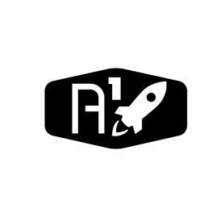DESIGN DOCUMENT

Area : Converse Engine

Category: Avionics (Power)

TEAM: Propulsion

Nyameaama Gambrah

**SUBCONTROLLER POWER**

Sub-Controller Stack

MICRO USB TO USB A

MICRO USB TO USB A

MICRO USB TO USB A

MICRO USB TO USB A

MICRO USB TO USB A

SBC 013

SBC 007

SBC 06

SBC 002

SBC 001